
Name: Abdul Samad
Program: BSSE Group A
Semester: 5th
Date: October 22, 2026
*-----------------------------------------------*

Lab Task 7.1
Task 3

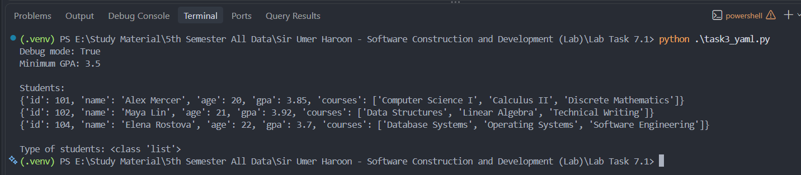

Reading Comparison:
In my opinion reading the students.yaml is easier that the students.json file because in the yaml we use indentation instead of the curly braces which increases the reading proficiency of the file. And for machine the json will be easier for machine to read as machine can easily identify the curly braces for it. If we talk about the comments so as we know that there are no comments supported in json and on other hand yaml natively supports comments.

Task 4
(A)

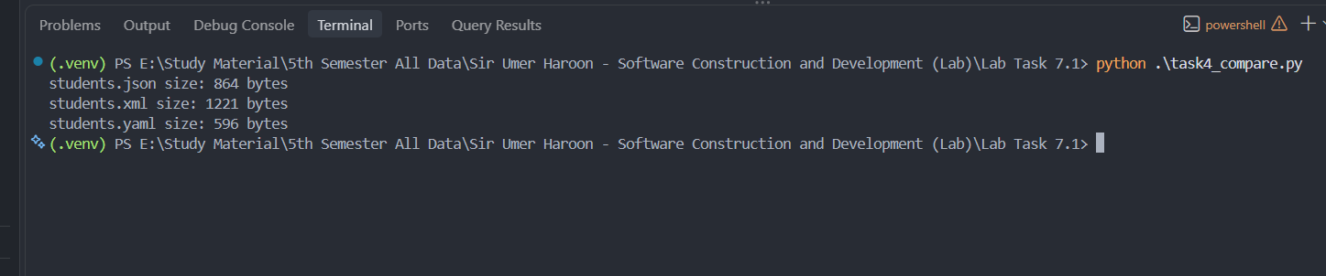

(B)

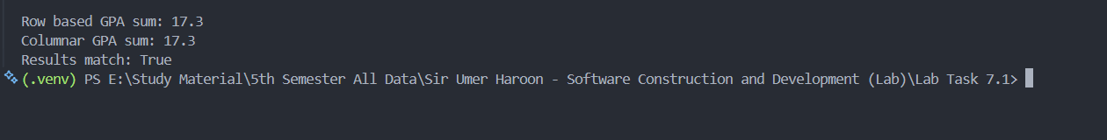

Columnar and Row sum comparison:

Columnar storage keeps values from the same column together on disk. When calculating a GPA sum, the system can read only the GPA column, skipping names, ages, and courses. This reduces the amount of data read and makes analytical queries more efficient.

(C)

1. Public REST API for a mobile app
I would choose JSON because it is easy to send and receive between a mobile app and a server. In our lab, JSON used less space than XML and required less code to load in Python. It is also widely supported, which makes it a good choice for a public API.

2. Configuration file for a DevOps pipeline
I would choose YAML because it is easy for me to read and edit. It uses indentation and supports comments, so we can explain what each setting does. In our lab, YAML also had the smallest file size.

3. Internal analytics system with millions of records
I would choose a columnar format because it stores the values of each column together. If we only need to calculate the average GPA, we can read the GPA column without reading names, ages, and courses. Our lab example showed how we can get the same result directly from a column.

4. Internal microservice with a response time under ten milliseconds
I would choose a binary format like Protocol Buffers because its messages are compact and designed for fast processing. This can help services exchange data quickly. We did not test binary formats in our lab, and the response time also depends on the network and the work done by the service.

*-----------------------------------------------*

The End

